**МИНИСТЕРСТВО ОБРАЗОВАНИЯ РЕСПУБЛИКИ БЕЛАРУСЬ**

**УЧРЕЖДЕНИЕ ОБРАЗОВАНИЯ**

**ГОМЕЛЬСКИЙ ГОСУДАРСТВЕННЫЙ ТЕХНИЧЕСКИЙ**

**УНИВЕРСИТЕТ ИМЕНИ П. О. СУХОГО**

Факультет автоматизированных и информационных систем

Кафедра «Информационные технологии»

ЛАБОРАТОРНАЯ РАБОТА №6

по дисциплине: **«Разработка приложений для мобильных устройств»**

на тему: **Фоновые задачи и службы**

Выполнил: студент гр. ИТП-31

Дашкевич Д.А.

Принял: ассистент

Белявский Е. В.

Гомель 2019

**Цель**: изучить программирование фоновых задач и служб в *Android*.

**Ход работы**

**Вариант 2**

# **Задание:**

Добавить в приложение, разработанное в лабораторной работе №3 фоновую службу, выполняющую периодическое сохранение данных приложения в файл. Выполнить запуск приложения на эмуляторе.

2. *Customer*: *id*, Фамилия, Имя, Отчество, Адрес, Номер кредитной карточки, Номер банковского счёта.

Создать массив объектов. Вывести:

а) список покупателей в алфавитном порядке;

б) список покупателей, у которых номер кредитной карточки находится в заданном интервале.

**Результат работы приложения:**

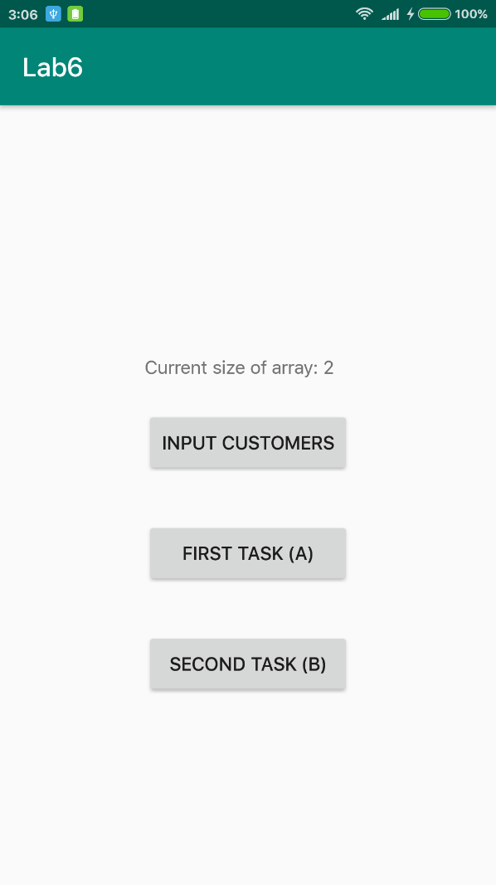

Рисунок 1 – Главное окно приложения с меню, у которого были сохранены две записи

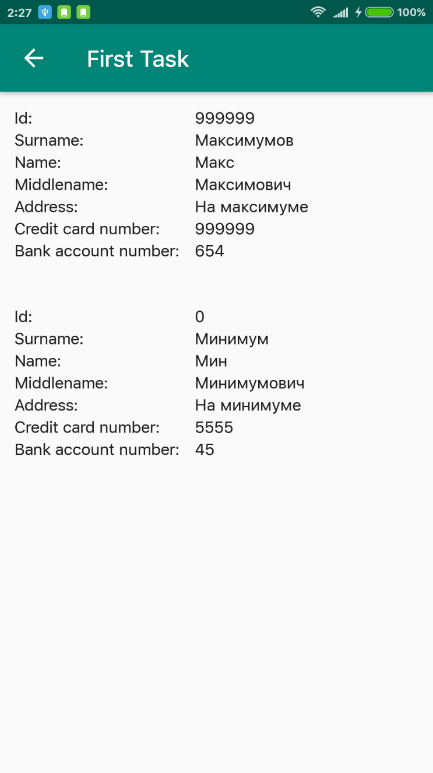

Рисунок 2 – Список клиентов в алфавитном порядке

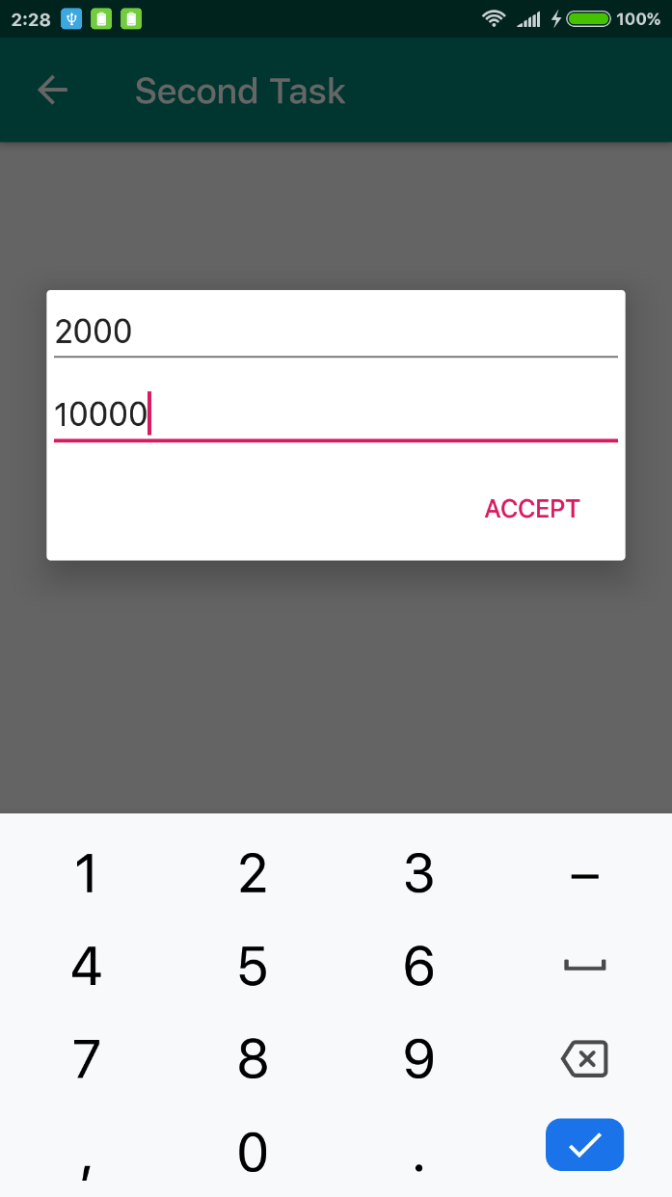

Рисунок 3 – Диалоговое окно ввода диапазона номеров кредитный карт

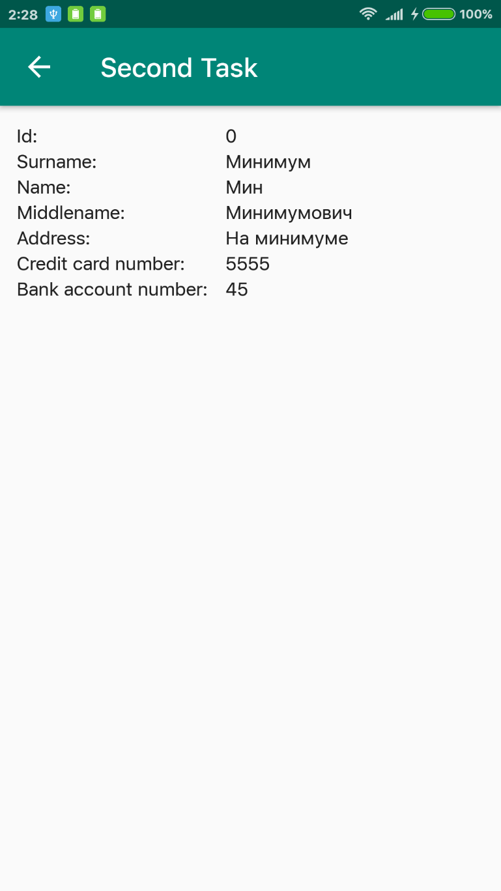

Рисунок 4 – Список клиентов с номерами кредитных карт в диапазон от 2000 до 10000

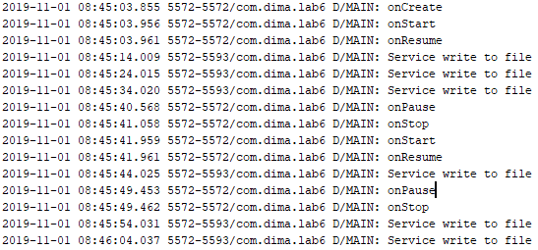

Рисунок 5 – Вывод логов в Android Studio. Каждые 10 секунд выводится лог с текстом “Service write to file”

**Вывод:** в результате выполнения лабораторной работы было изучено программирование фоновых задач и служб в Android, также написано и запущено приложение.

**Приложение А**

**Исходный код приложения**

**MainActivity.java:**

**public class** MainActivity **extends** AppCompatActivity {  
  
 **private static final** String ***CURRENT_SIZE_STRING*** = **"Current size of array: "**;  
  
 **private** TextView **mCurrentSizeTextView**;  
  
 @Override  
 **protected void** onCreate(Bundle savedInstanceState) {  
 **super**.onCreate(savedInstanceState);  
 Log.*d*(**"MAIN"**, **"onCreate"**);  
 setContentView(R.layout.***activity_main***);  
 bindButtons();  
  
 **mCurrentSizeTextView** = findViewById(R.id.***currentSizeOfArrayTextView***);  
  
 **int** size = CustomerList.*readFile*(**this**);  
 String t = ***CURRENT_SIZE_STRING*** + size;  
 **mCurrentSizeTextView**.setText(t);  
  
 startService(**new** Intent(**this**, SaveService.**class**));  
 }  
  
 @Override  
 **protected void** onStart() {  
 **super**.onStart();  
 Log.*d*(**"MAIN"**, **"onStart"**);  
 }  
  
 @Override  
 **protected void** onResume() {  
 **super**.onResume();  
 Log.*d*(**"MAIN"**, **"onResume"**);  
 }  
  
 @Override  
 **protected void** onPause() {  
 **super**.onPause();  
 Log.*d*(**"MAIN"**, **"onPause"**);  
 }  
  
 @Override  
 **protected void** onStop() {  
 **super**.onStop();  
 Log.*d*(**"MAIN"**, **"onStop"**);  
 }  
  
 @Override  
 **protected void** onDestroy() {  
 Log.*d*(**"MAIN"**, **"onDestroy"**);  
 stopService(**new** Intent(**this**, SaveService.**class**));  
 **super**.onDestroy();  
 }  
  
  
 **private void** bindButtons() {  
 Button inputButton = findViewById(R.id.***inputCustomersButton***);  
 Button openFirstActivityButton = findViewById(R.id.***firstTaskButton***);  
 Button openSecondActivityButton = findViewById(R.id.***secondTaskButton***);  
  
 inputButton.setOnClickListener(**new** View.OnClickListener() {  
 @Override  
 **public void** onClick(View v) {  
 MainActivity.**this**.openInputArraySizeDialog();  
 }  
 });  
  
 openFirstActivityButton.setOnClickListener(**new** View.OnClickListener() {  
 @Override  
 **public void** onClick(View v) {  
 **if** (CustomerList.*getInstance*() != **null**) {  
 startActivity(**new** Intent(MainActivity.**this**, FirstActivity.**class**));  
 } **else** {  
 Toast.*makeText*(v.getContext(), **"No data available!"**, Toast.***LENGTH_SHORT***).show();  
 }  
  
 }  
 });  
  
 openSecondActivityButton.setOnClickListener(**new** View.OnClickListener() {  
 @Override  
 **public void** onClick(View v) {  
 **if** (CustomerList.*getInstance*() != **null**) {  
 startActivity(**new** Intent(MainActivity.**this**, SecondActivity.**class**));  
 } **else** {  
 Toast.*makeText*(v.getContext(), **"No data available!"**, Toast.***LENGTH_SHORT***).show();  
 }  
 }  
 });  
 }  
  
  
 **private void** openInputArraySizeDialog() {  
 createInputArraySizeDialog().show();  
 }  
  
 @SuppressLint(**"InflateParams"**)  
 **private** AlertDialog createInputArraySizeDialog() {  
 AlertDialog.Builder builder = **new** AlertDialog.Builder(**this**);  
 LayoutInflater inflater = **this**.getLayoutInflater();  
 **final** View view = inflater.inflate(R.layout.***input_array_size_dialog***, **null**);  
 builder.setView(view)  
 .setPositiveButton(**"Accept"**, **new** DialogInterface.OnClickListener() {  
 @Override  
 **public void** onClick(DialogInterface dialog, **int** id) {  
 acceptArraySizeDialog(view);  
 }  
 }).setNegativeButton(**"Cancel"**, **new** DialogInterface.OnClickListener() {  
 @Override  
 **public void** onClick(DialogInterface dialog, **int** which) {  
 dialog.dismiss();  
 }  
 }).setCancelable(**false**);  
 **return** builder.create();  
 }  
  
 **private void** acceptArraySizeDialog(View view) {  
 EditText sizeOfArrayEditText = view.findViewById(R.id.***sizeOfArrayEditText***);  
 String s = sizeOfArrayEditText.getText().toString();  
 **if** (!s.isEmpty()) {  
 **int** size = Integer.*valueOf*(s);  
 **if** (size > 0) {  
 CustomerList.*createInstance*(size);  
 String t = ***CURRENT_SIZE_STRING*** + size;  
 **mCurrentSizeTextView**.setText(t);  
 openInputCustomerDialog();  
 } **else** {  
 Toast.*makeText*(getApplicationContext(), **"Size must be positive!"**,  
 Toast.***LENGTH_SHORT***).show();  
 }  
 } **else** {  
 Toast.*makeText*(getApplicationContext(), **"The input field must be filled in!"**,  
 Toast.***LENGTH_SHORT***).show();  
 }  
 }  
  
  
 **private void** openInputCustomerDialog() {  
 AlertDialog dialog = createInputCustomerDialog();  
 dialog.show();  
 }  
  
 @SuppressLint(**"InflateParams"**)  
 **private** AlertDialog createInputCustomerDialog() {  
 AlertDialog.Builder builder = **new** AlertDialog.Builder(**this**);  
 LayoutInflater inflater = **this**.getLayoutInflater();  
 **final** View view = inflater.inflate(R.layout.***input_customer_dialog***, **null**);  
 builder.setView(view)  
 .setPositiveButton(**"Add"**, **new** DialogInterface.OnClickListener() {  
 @Override  
 **public void** onClick(DialogInterface dialog, **int** id) {  
 addCustomer(view);  
 **if** (CustomerList.*getInstance*().getSize() != CustomerList.*getInstance*().getRecentlyAddedIndex()) {  
 openInputCustomerDialog();  
 }  
 }  
 }).setCancelable(**false**);  
 **return** builder.create();  
 }  
  
 **private void** addCustomer(View view) {  
 String customerSurname = ((EditText)  
 view.findViewById(R.id.***customerSurnameEditText***)).getText().toString();  
 String customerName = ((EditText)  
 view.findViewById(R.id.***customerNameEditText***)).getText().toString();  
 String customerMiddlename = ((EditText)  
 view.findViewById(R.id.***customerMiddlenameEditText***)).getText().toString();  
 String customerAddress = ((EditText)  
 view.findViewById(R.id.***customerAddressEditText***)).getText().toString();  
 **try** {  
 **int** customerId = Integer.*valueOf*(((EditText)  
 view.findViewById(R.id.***customerIdEditText***)).getText().toString());  
 **long** customerCreditCardNumber = Long.*valueOf*(((EditText)  
 view.findViewById(R.id.***customerCreditCardNumberEditText***)).getText().toString());  
 **long** customerBankAccountNumber = Long.*valueOf*(((EditText)  
 view.findViewById(R.id.***customerBankAccountNumberEditText***)).getText().toString());  
 CustomerList.*getInstance*().addCustomer(**new** Customer(customerId, customerSurname,  
 customerName, customerMiddlename, customerAddress, customerCreditCardNumber,  
 customerBankAccountNumber));  
 } **catch** (NumberFormatException ex) {  
 Toast.*makeText*(**this**, **"Input fields must be filled in!"**, Toast.***LENGTH_SHORT***).show();  
 }  
 }  
}

**FirstActivity.java:**

**public class** FirstActivity **extends** AppCompatActivity {  
 @Override  
 **protected void** onCreate(@Nullable Bundle savedInstanceState) {  
 **super**.onCreate(savedInstanceState);  
 setContentView(R.layout.***activity_first***);  
 ActionBar actionBar = getSupportActionBar();  
 **if** (actionBar != **null**) {  
 actionBar.setHomeButtonEnabled(**true**);  
 actionBar.setDisplayHomeAsUpEnabled(**true**);  
 }  
 setDataForRecyclerView();  
 }  
  
 **private void** setDataForRecyclerView() {  
 RecyclerView recyclerView = findViewById(R.id.***customersRecyclerView***);  
 recyclerView.setHasFixedSize(**true**);  
 recyclerView.setLayoutManager(**new** LinearLayoutManager(**this**));  
 recyclerView.setAdapter(**new** CustomersAdapter(CustomerList.*getInstance*()  
 .getCustomerArrayInAlphabeticalOrder()));  
 }  
  
  
 @Override  
 **public boolean** onOptionsItemSelected(MenuItem item) {  
 **if** (item.getItemId() == android.R.id.***home***) {  
 **this**.finish();  
 **return true**;  
 }  
 **return super**.onOptionsItemSelected(item);  
 }  
}

**SecondActivity.java:**

**public class** SecondActivity **extends** AppCompatActivity {  
 @Override  
 **protected void** onCreate(@Nullable Bundle savedInstanceState) {  
 **super**.onCreate(savedInstanceState);  
 setContentView(R.layout.***activity_second***);  
 ActionBar actionBar = getSupportActionBar();  
 **if** (actionBar != **null**) {  
 actionBar.setHomeButtonEnabled(**true**);  
 actionBar.setDisplayHomeAsUpEnabled(**true**);  
 }  
 openInputRangeDialog();  
 }  
  
 **private void** setDataForRecyclerView(View itemView) {  
 **try** {  
 **long** begin = Long.*valueOf*(((EditText)  
 itemView.findViewById(R.id.***beginEditText***)).getText().toString());  
 **long** end = Long.*valueOf*(((EditText)  
 itemView.findViewById(R.id.***endEditText***)).getText().toString());  
 RecyclerView recyclerView = findViewById(R.id.***customersRecyclerView***);  
 recyclerView.setHasFixedSize(**true**);  
 recyclerView.setLayoutManager(**new** LinearLayoutManager(**this**));  
 recyclerView.setAdapter(**new** CustomersAdapter(CustomerList.*getInstance*()  
 .getCustomerArrayWithCardNumbersInRange(begin, end)));  
 } **catch** (NumberFormatException ex) {  
 Toast.*makeText*(**this**, **"Input fields must be filled in!"**, Toast.***LENGTH_SHORT***).show();  
 openInputRangeDialog();  
 }  
  
 }  
  
 **private void** openInputRangeDialog() {  
 createInputRangeDialog().show();  
 }  
  
 @SuppressLint(**"InflateParams"**)  
 **private** AlertDialog createInputRangeDialog() {  
 AlertDialog.Builder builder = **new** AlertDialog.Builder(**this**);  
 LayoutInflater inflater = **this**.getLayoutInflater();  
 **final** View view = inflater.inflate(R.layout.***input_range_dialog***, **null**);  
 builder.setView(view)  
 .setPositiveButton(**"Accept"**, **new** DialogInterface.OnClickListener() {  
 @Override  
 **public void** onClick(DialogInterface dialog, **int** id) {  
 setDataForRecyclerView(view);  
 }  
 }).setCancelable(**false**);  
 **return** builder.create();  
 }  
  
 @Override  
 **public boolean** onOptionsItemSelected(MenuItem item) {  
 **if** (item.getItemId() == android.R.id.***home***) {  
 **this**.finish();  
 **return true**;  
 }  
 **return super**.onOptionsItemSelected(item);  
 }  
}

**CustomersAdapter.java:**

**public class** CustomersAdapter **extends** RecyclerView.Adapter<CustomersAdapter.CustomerViewHolder> {  
  
 **private** List<Customer> mCustomers;  
  
 **public** CustomersAdapter(List<Customer> customers) {  
 **this**.mCustomers = customers;  
 }  
  
 @NonNull  
 @Override  
 **public** CustomerViewHolder onCreateViewHolder(@NonNull ViewGroup viewGroup, **int** i) {  
 View view = LayoutInflater.from(viewGroup.getContext())  
 .inflate(R.layout.customer_item, viewGroup, **false**);  
 **return new** CustomerViewHolder(view);  
 }  
  
  
 @Override  
 **public void** onBindViewHolder(@NonNull CustomersAdapter.CustomerViewHolder holder, **int** position) {  
 Customer customer = mCustomers.get(position);  
 holder.idView.setText(String.valueOf(customer.getId()));  
 holder.surnameView.setText(customer.getSurname());  
 holder.nameView.setText(customer.getName());  
 holder.middlenameView.setText(customer.getMiddlename());  
 holder.addressView.setText(customer.getAddress());  
 holder.creditCardNumberView.setText(String.valueOf(customer.getCreditCardNumber()));  
 holder.bankAccountNumberView.setText(String.valueOf(customer.getBankAccountNumber()));  
 }  
  
 @Override  
 **public int** getItemCount() {  
 **return** mCustomers.size();  
 }  
  
 **class** CustomerViewHolder **extends** RecyclerView.ViewHolder {  
 TextView idView, surnameView, nameView, middlenameView,  
 addressView, creditCardNumberView, bankAccountNumberView;  
  
 CustomerViewHolder(@NonNull View view) {  
 **super**(view);  
 idView = view.findViewById(R.id.customerIdTextView);  
 surnameView = view.findViewById(R.id.customerSurnameTextView);  
 nameView = view.findViewById(R.id.customerNameTextView);  
 middlenameView = view.findViewById(R.id.customerMiddlenameTextView);  
 addressView = view.findViewById(R.id.customerAddressTextView);  
 creditCardNumberView = view.findViewById(R.id.customerCreditCardNumberTextView);  
 bankAccountNumberView = view.findViewById(R.id.customerBankAccountNumberTextView);  
 }  
 }  
}

**Customer.java:**

**public class** Customer {  
  
 **private int mId**;  
 **private** String **mSurname**;  
 **private** String **mName**;  
 **private** String **middlename**;  
 **private** String **mAddress**;  
 **private long mCreditCardNumber**;  
 **private long mBankAccountNumber**;  
  
 **public** Customer(**int** id, String surname, String name, String middlename, String address,  
 **long** creditCardNumber, **long** bankAccountNumber) {  
 **this**.**mId** = id;  
 **this**.**mSurname** = surname;  
 **this**.**mName** = name;  
 **this**.**middlename** = middlename;  
 **this**.**mAddress** = address;  
 **this**.**mCreditCardNumber** = creditCardNumber;  
 **this**.**mBankAccountNumber** = bankAccountNumber;  
 }  
  
 **public int** getId() {  
 **return mId**;  
 }  
  
 **public** String getSurname() {  
 **return mSurname**;  
 }  
  
 **public** String getName() {  
 **return mName**;  
 }  
  
 **public** String getMiddlename() {  
 **return middlename**;  
 }  
  
 **public** String getAddress() {  
 **return mAddress**;  
 }  
  
 **public long** getCreditCardNumber() {  
 **return mCreditCardNumber**;  
 }  
  
 **public long** getBankAccountNumber() {  
 **return mBankAccountNumber**;  
 }  
}

**CustomerList.java:**

**public class** CustomerList {  
  
 **private static final** String ***FILENAME*** = **"file.txt"**;  
  
 **private static** CustomerList *sCustomerList* = **null**;  
  
 **private** List<Customer> **mCustomers**;  
 **private int mRecentlyAddedIndex** = 0;  
  
 **private** CustomerList(**int** maxSize) {  
 **this**.**mCustomers** = **new** ArrayList<>(maxSize);  
 }  
  
 **public static void** createInstance(**int** size) {  
 *sCustomerList* = **new** CustomerList(size);  
 }  
  
 **public static** CustomerList getInstance() {  
 **return** *sCustomerList*;  
 }  
  
 **public void** addCustomer(Customer customer) {  
 **if** (**mRecentlyAddedIndex** < **mCustomers**.size()) {  
 **mCustomers**.set(**mRecentlyAddedIndex**++, customer);  
 }  
 }  
  
 **private** List<Customer> getArray() {  
 **return mCustomers**;  
 }  
  
 **public int** getRecentlyAddedIndex() {  
 **return mRecentlyAddedIndex**;  
 }  
  
 **public int** getSize() {  
 **return mCustomers**.size();  
 }  
  
 **public** List<Customer> getCustomerArrayInAlphabeticalOrder() {  
 List<Customer> customers = **new** ArrayList<>(**mCustomers**);  
 Collections.*sort*(customers, **new** Comparator<Customer>() {  
 @Override  
 **public int** compare(Customer o1, Customer o2) {  
 **return** o1.getSurname().compareTo(o2.getSurname());  
 }  
 });  
 **return** customers;  
 }  
  
 **public** List<Customer> getCustomerArrayWithCardNumbersInRange(**long** begin, **long** end) {  
 List<Customer> customers = **new** ArrayList<>();  
 **for** (Customer customer : **mCustomers**) {  
 **if** (customer.getCreditCardNumber() >= begin && customer.getCreditCardNumber() <= end) {  
 customers.add(customer);  
 }  
 }  
 **return** customers;  
 }  
  
 **public static void** writeFile(Context context) {  
 **if** (CustomerList.*getInstance*() == **null**) {  
 **return**;  
 }  
 **int** size = CustomerList.*getInstance*().getSize();  
 **if** (size > 0) {  
 **try** {  
 ObjectOutputStream objectOutputStream = **new** ObjectOutputStream(context  
 .openFileOutput(***FILENAME***, Context.***MODE_PRIVATE***));  
 objectOutputStream.writeInt(CustomerList.*getInstance*().getSize());  
 List<Customer> array = CustomerList.*getInstance*().getArray();  
 **for** (**int** i = 0; i < size; i++) {  
 objectOutputStream.writeObject(array.get(i));  
 }  
 objectOutputStream.close();  
 } **catch** (IOException ex) {  
 Log.*d*(**"MAIN"**, ex.getMessage());  
 }  
 }  
 }  
  
 **public static int** readFile(Context context) {  
 **try** {  
 ObjectInputStream objectInputStream = **new** ObjectInputStream(context.openFileInput(***FILENAME***));  
 **int** size = objectInputStream.readInt();  
 CustomerList.*createInstance*(size);  
 **for** (**int** i = 0; i < size; i++) {  
 CustomerList.*getInstance*().addCustomer((Customer) objectInputStream.readObject());  
 }  
 **return** size;  
 } **catch** (IOException | ClassNotFoundException ex) {  
 Log.*d*(**"MAIN"**, ex.getMessage() == **null** ? **""** : ex.getMessage());  
 **return** 0;  
 }  
 }  
}

**SaveService.java:**

**public class** SaveService **extends** Service {  
  
 **private static final int *PAUSE*** = 10000;  
  
 **private** Thread **mThread**;  
  
 **private** Runnable **runnable** = **new** Runnable() {  
 @Override  
 **public void** run() {  
 **while** (**true**) {  
 **try** {  
 Thread.*sleep*(***PAUSE***);  
 } **catch** (InterruptedException e) {  
 e.printStackTrace();  
 **return**;  
 }  
 **if** (CustomerList.*getInstance*() != **null**) {  
 CustomerList.*writeFile*(SaveService.**this**);  
 Log.*d*(**"MAIN"**, **"Service write to file"**);  
 }  
 }  
 }  
 };  
  
 @Override  
 **public int** onStartCommand(**final** Intent intent, **int** flags, **int** startId) {  
 **mThread** = **new** Thread(**runnable**);  
 **mThread**.start();  
 **return super**.onStartCommand(intent, flags, startId);  
 }  
  
 @Override  
 **public void** onDestroy() {  
 **mThread**.interrupt();  
 **super**.onDestroy();  
 }  
  
 @Override  
 **public** IBinder onBind(Intent intent) {  
 **return null**;  
 }  
}

**activity_main.xml:**

*<?***xml version="1.0" encoding="utf-8"***?>*<**androidx.constraintlayout.widget.ConstraintLayout xmlns:android="http://schemas.android.com/apk/res/android"  
 xmlns:app="http://schemas.android.com/apk/res-auto"  
 xmlns:tools="http://schemas.android.com/tools"  
 android:layout_width="match_parent"  
 android:layout_height="match_parent"  
 tools:context=".controller.MainActivity"**>  
  
 <**TextView  
 android:id="@+id/currentSizeOfArrayTextView"  
 android:layout_width="150dp"  
 android:layout_height="wrap_content"  
 android:layout_marginStart="8dp"  
 android:layout_marginTop="180dp"  
 android:layout_marginEnd="8dp"  
 app:layout_constraintEnd_toEndOf="parent"  
 app:layout_constraintHorizontal_bias="0.5"  
 app:layout_constraintStart_toStartOf="parent"  
 app:layout_constraintTop_toTopOf="parent"** />  
  
 <**Button  
 android:id="@+id/inputCustomersButton"  
 android:layout_width="150dp"  
 android:layout_height="wrap_content"  
 android:layout_marginStart="8dp"  
 android:layout_marginTop="220dp"  
 android:layout_marginEnd="8dp"  
 android:text="@string/input_customers"  
 app:layout_constraintEnd_toEndOf="parent"  
 app:layout_constraintHorizontal_bias="0.5"  
 app:layout_constraintStart_toStartOf="parent"  
 app:layout_constraintTop_toTopOf="parent"** />  
  
 <**Button  
 android:id="@+id/firstTaskButton"  
 android:layout_width="150dp"  
 android:layout_height="wrap_content"  
 android:layout_marginStart="8dp"  
 android:layout_marginTop="300dp"  
 android:layout_marginEnd="8dp"  
 android:text="@string/first_task_a"  
 app:layout_constraintEnd_toEndOf="parent"  
 app:layout_constraintHorizontal_bias="0.5"  
 app:layout_constraintStart_toStartOf="parent"  
 app:layout_constraintTop_toTopOf="parent"** />  
  
 <**Button  
 android:id="@+id/secondTaskButton"  
 android:layout_width="150dp"  
 android:layout_height="wrap_content"  
 android:layout_marginStart="8dp"  
 android:layout_marginTop="380dp"  
 android:layout_marginEnd="8dp"  
 android:text="@string/second_task_b"  
 app:layout_constraintEnd_toEndOf="parent"  
 app:layout_constraintHorizontal_bias="0.5"  
 app:layout_constraintStart_toStartOf="parent"  
 app:layout_constraintTop_toTopOf="parent"** />  
  
</**androidx.constraintlayout.widget.ConstraintLayout**>

**input_array_size_dialog.xml:**

*<?***xml version="1.0" encoding="utf-8"***?>*<**LinearLayout xmlns:android="http://schemas.android.com/apk/res/android"  
 xmlns:tools="http://schemas.android.com/tools"  
 android:orientation="vertical" android:layout_width="match_parent"  
 android:layout_height="match_parent"**>  
  
 <**EditText  
 android:id="@+id/sizeOfArrayEditText"  
 android:layout_width="match_parent"  
 android:layout_height="wrap_content"  
 android:hint="@string/enter_size_of_array"  
 android:importantForAutofill="no"  
 android:inputType="number"  
 tools:ignore="LabelFor"  
 tools:targetApi="o"** />  
  
</**LinearLayout**>

**input_customer_dialog.xml:**

*<?***xml version="1.0" encoding="utf-8"***?>*<**LinearLayout xmlns:android="http://schemas.android.com/apk/res/android"  
 xmlns:tools="http://schemas.android.com/tools"  
 android:orientation="vertical" android:layout_width="match_parent"  
 android:layout_height="match_parent"**>  
  
 <**EditText  
 android:id="@+id/customerIdEditText"  
 android:layout_width="match_parent"  
 android:layout_height="wrap_content"  
 android:hint="@string/enter_id"  
 android:importantForAutofill="no"  
 android:inputType="number"  
 tools:ignore="LabelFor"  
 tools:targetApi="o"** />  
  
 <**EditText  
 android:id="@+id/customerSurnameEditText"  
 android:layout_width="match_parent"  
 android:layout_height="wrap_content"  
 android:hint="@string/enter_surname"  
 android:importantForAutofill="no"  
 android:inputType="text"  
 tools:ignore="LabelFor"  
 tools:targetApi="o"** />  
  
 <**EditText  
 android:id="@+id/customerNameEditText"  
 android:layout_width="match_parent"  
 android:layout_height="wrap_content"  
 android:hint="@string/enter_name"  
 android:importantForAutofill="no"  
 android:inputType="text"  
 tools:ignore="LabelFor"  
 tools:targetApi="o"** />  
  
 <**EditText  
 android:id="@+id/customerMiddlenameEditText"  
 android:layout_width="match_parent"  
 android:layout_height="wrap_content"  
 android:hint="@string/enter_middlename"  
 android:importantForAutofill="no"  
 android:inputType="text"  
 tools:ignore="LabelFor"  
 tools:targetApi="o"** />  
  
 <**EditText  
 android:id="@+id/customerAddressEditText"  
 android:layout_width="match_parent"  
 android:layout_height="wrap_content"  
 android:hint="@string/enter_address"  
 android:importantForAutofill="no"  
 android:inputType="text"  
 tools:ignore="LabelFor"  
 tools:targetApi="o"** />  
  
 <**EditText  
 android:id="@+id/customerCreditCardNumberEditText"  
 android:layout_width="match_parent"  
 android:layout_height="wrap_content"  
 android:hint="@string/enter_credit_card_number"  
 android:importantForAutofill="no"  
 android:inputType="number"  
 tools:ignore="LabelFor"  
 tools:targetApi="o"** />  
  
 <**EditText  
 android:id="@+id/customerBankAccountNumberEditText"  
 android:layout_width="match_parent"  
 android:layout_height="wrap_content"  
 android:hint="@string/enter_bank_account_number"  
 android:importantForAutofill="no"  
 android:inputType="number"  
 tools:ignore="LabelFor"  
 tools:targetApi="o"** />  
  
</**LinearLayout**>

**input_range_dialog.xml:**

*<?***xml version="1.0" encoding="utf-8"***?>*<**LinearLayout xmlns:android="http://schemas.android.com/apk/res/android"  
 xmlns:tools="http://schemas.android.com/tools"  
 android:orientation="vertical"  
 android:layout_width="match_parent"  
 android:layout_height="match_parent"**>  
  
 <**EditText  
 android:id="@+id/beginEditText"  
 android:layout_width="match_parent"  
 android:layout_height="wrap_content"  
 android:hint="@string/enter_begin_of_range"  
 android:importantForAutofill="no"  
 android:inputType="number"  
 tools:ignore="LabelFor"  
 tools:targetApi="o"** />  
  
 <**EditText  
 android:id="@+id/endEditText"  
 android:layout_width="match_parent"  
 android:layout_height="wrap_content"  
 android:hint="@string/enter_end_of_range"  
 android:importantForAutofill="no"  
 android:inputType="number"  
 tools:ignore="LabelFor"  
 tools:targetApi="o"** />  
  
</**LinearLayout**>

**activity_first.xml:**

*<?***xml version="1.0" encoding="utf-8"***?>*<**androidx.constraintlayout.widget.ConstraintLayout  
 xmlns:android="http://schemas.android.com/apk/res/android" android:layout_width="match_parent"  
 android:layout_height="match_parent"**>  
  
 <**androidx.recyclerview.widget.RecyclerView  
 android:id="@+id/customersRecyclerView"  
 android:layout_width="match_parent"  
 android:layout_height="match_parent"**/>  
  
</**androidx.constraintlayout.widget.ConstraintLayout**>

**activity_second.xml:**

*<?***xml version="1.0" encoding="utf-8"***?>*<**androidx.constraintlayout.widget.ConstraintLayout  
 xmlns:android="http://schemas.android.com/apk/res/android" android:layout_width="match_parent"  
 android:layout_height="match_parent"**>  
  
 <**androidx.recyclerview.widget.RecyclerView  
 android:id="@+id/customersRecyclerView"  
 android:layout_width="match_parent"  
 android:layout_height="match_parent"**/>  
  
</**androidx.constraintlayout.widget.ConstraintLayout**>

**customer_item.xml:**

*<?***xml version="1.0" encoding="utf-8"***?>*<**LinearLayout xmlns:android="http://schemas.android.com/apk/res/android"  
 android:orientation="vertical" android:layout_width="match_parent"  
 android:layout_height="wrap_content"  
 android:layout_marginBottom="12dp"  
 android:padding="12dp"**>  
  
 <**LinearLayout  
 android:layout_width="match_parent"  
 android:layout_height="wrap_content"  
 android:orientation="horizontal"**>  
  
 <**TextView  
 android:layout_width="150dp"  
 android:layout_height="wrap_content"  
 android:text="@string/id"  
 android:textAppearance="@style/TextAppearance.AppCompat.Body1"** />  
 <**TextView  
 android:id="@+id/customerIdTextView"  
 android:layout_width="match_parent"  
 android:layout_height="wrap_content"  
 android:textAppearance="@style/TextAppearance.AppCompat.Body1"**/>  
 </**LinearLayout**>  
 <**LinearLayout  
 android:layout_width="match_parent"  
 android:layout_height="wrap_content"  
 android:orientation="horizontal"**>  
 <**TextView  
 android:layout_width="150dp"  
 android:layout_height="wrap_content"  
 android:text="@string/surname"  
 android:textAppearance="@style/TextAppearance.AppCompat.Body1"** />  
 <**TextView  
 android:id="@+id/customerSurnameTextView"  
 android:layout_width="match_parent"  
 android:layout_height="wrap_content"  
 android:textAppearance="@style/TextAppearance.AppCompat.Body1"**/>  
 </**LinearLayout**>  
  
 <**LinearLayout  
 android:layout_width="match_parent"  
 android:layout_height="wrap_content"  
 android:orientation="horizontal"**>  
 <**TextView  
 android:layout_width="150dp"  
 android:layout_height="wrap_content"  
 android:text="@string/name"  
 android:textAppearance="@style/TextAppearance.AppCompat.Body1"** />  
 <**TextView  
 android:id="@+id/customerNameTextView"  
 android:layout_width="match_parent"  
 android:layout_height="wrap_content"  
 android:textAppearance="@style/TextAppearance.AppCompat.Body1"**/>  
 </**LinearLayout**>  
  
 <**LinearLayout  
 android:layout_width="match_parent"  
 android:layout_height="wrap_content"  
 android:orientation="horizontal"**>  
  
 <**TextView  
 android:layout_width="150dp"  
 android:layout_height="wrap_content"  
 android:text="@string/middlename"  
 android:textAppearance="@style/TextAppearance.AppCompat.Body1"** />  
  
 <**TextView  
 android:id="@+id/customerMiddlenameTextView"  
 android:layout_width="match_parent"  
 android:layout_height="wrap_content"  
 android:textAppearance="@style/TextAppearance.AppCompat.Body1"**/>  
 </**LinearLayout**>  
  
 <**LinearLayout  
 android:layout_width="match_parent"  
 android:layout_height="wrap_content"  
 android:orientation="horizontal"**>  
  
 <**TextView  
 android:layout_width="150dp"  
 android:layout_height="wrap_content"  
 android:text="@string/address"  
 android:textAppearance="@style/TextAppearance.AppCompat.Body1"** />  
  
 <**TextView  
 android:id="@+id/customerAddressTextView"  
 android:layout_width="match_parent"  
 android:layout_height="wrap_content"  
 android:textAppearance="@style/TextAppearance.AppCompat.Body1"**/>  
 </**LinearLayout**>  
  
 <**LinearLayout  
 android:layout_width="match_parent"  
 android:layout_height="wrap_content"  
 android:orientation="horizontal"**>  
  
 <**TextView  
 android:layout_width="150dp"  
 android:layout_height="wrap_content"  
 android:text="@string/credit_card_number"  
 android:textAppearance="@style/TextAppearance.AppCompat.Body1"** />  
  
 <**TextView  
 android:id="@+id/customerCreditCardNumberTextView"  
 android:layout_width="match_parent"  
 android:layout_height="wrap_content"  
 android:textAppearance="@style/TextAppearance.AppCompat.Body1"**/>  
 </**LinearLayout**>  
  
 <**LinearLayout  
 android:layout_width="match_parent"  
 android:layout_height="wrap_content"  
 android:orientation="horizontal"**>  
 <**TextView  
 android:layout_width="150dp"  
 android:layout_height="wrap_content"  
 android:text="@string/bank_account_number"  
 android:textAppearance="@style/TextAppearance.AppCompat.Body1"** />  
 <**TextView  
 android:id="@+id/customerBankAccountNumberTextView"  
 android:layout_width="match_parent"  
 android:layout_height="wrap_content"  
 android:textAppearance="@style/TextAppearance.AppCompat.Body1"**/>  
 </**LinearLayout**>  
  
</**LinearLayout**>